**Marketing Insight Report**

1. Introduction
   * Dataset Overview

The dataset contains **9,994 rows** of transaction data with **13 columns**, covering details on customer demographics, product categories, and sales performance. Key attributes include **Ship Mode, Segment, Country, City, State, Postal Code, and Region**, which describe customer location and order type. Product details are categorized under **Category and Sub-Category**, while financial metrics include **Sales, Quantity, Discount, and Profit**, providing insights into revenue and profitability.

* + Project Overview

The purpose of this project is to examine the dataset and identify insights in the data and give actionable.

1. Observations
   * **Total Revenue**: (Sales × Quantity) − (Discount × Sales)
   * **Profit Margin**: Derived to assess profitability post-costs.
   * Top-Selling Products

* By total revenue:
  + **Binders** dominate ($128,605), followed by **Paper** and **Furnishings**.
  + **Appliances** generate minimal revenue ($0.09) due to excessive discounts (up to 45%).
* **By Quantity Sold**:
  + **Binders** (5,971 units) and **Paper** (5,144 units) lead sales volume.
  + **Appliances** sell the fewest units (1,729).
* **By Profit**:
* **Copiers** drive the highest profit ($55,618).
* **Tables** incur losses (-$17,725) due to high discounts and low margins.
  + Profitability Analysis
    - **Discount Impact**:
      * High discounts correlate with losses (e.g., **Appliances**, **Tables**).
      * No linear relationship between discounts and sales volume (see *Sales vs. Discount* plot).
    - **Profit Margins**:
      * Negative margins in **Tables** and **Bookcases** indicate pricing/cost inefficiencies
  + Discount Analysis
    - The graph (Sales vs Discount) bellow suggests that there is no linear relationship between sales and discount, that is, higher discount does not always translate to more sales

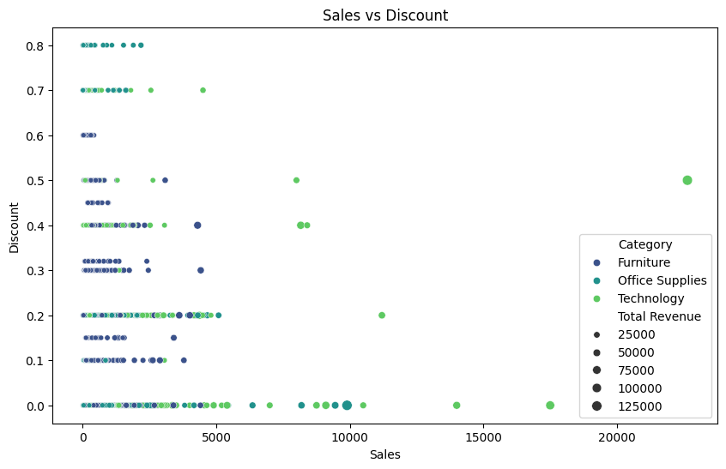

* + - The graph below (Profit vs Discount) suggests that higher discount is often associated with lower or negative profit, indicating excessive discounting which may hurt the business' profitability.

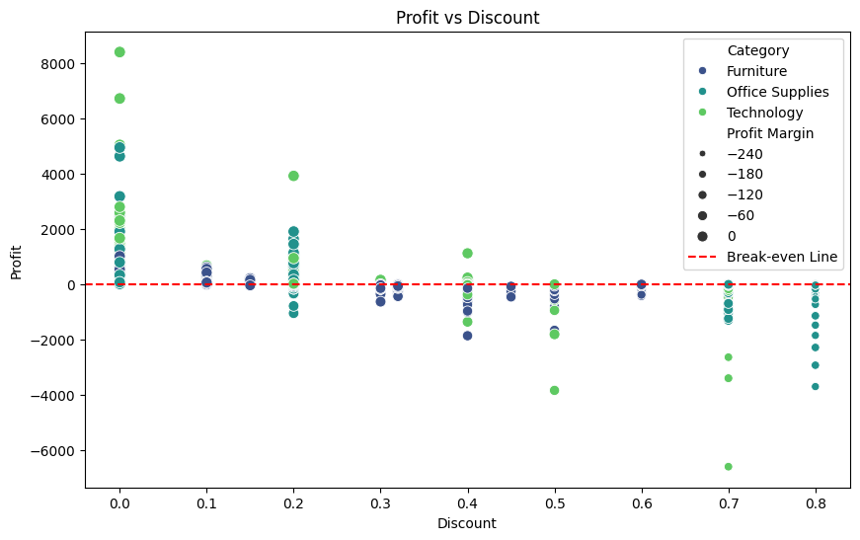

* From both visualizations above it can be inferred that the major source of the company’s loss come from heavy discounting.
  + Demographic Analysis
    - From the graph below It can be inferred that:

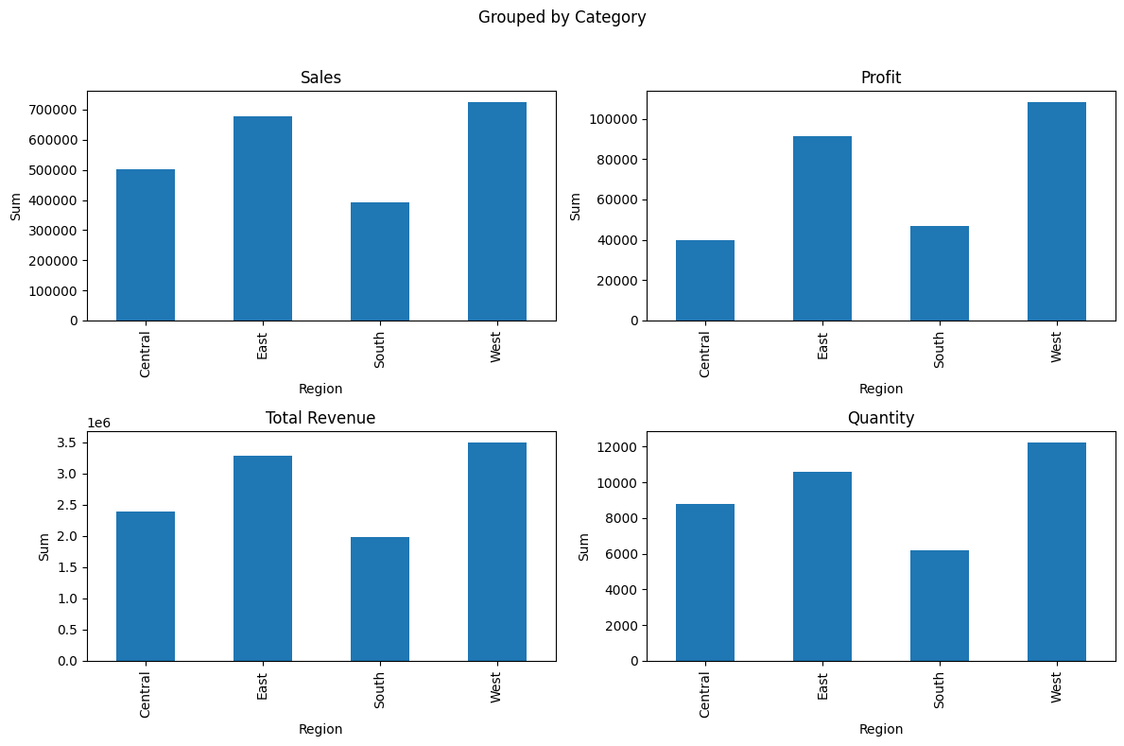

* + - The West region dominates in sales, profit, revenue and quantity sold, followed by East as a strong contender; the central region underperforms across all metrics, while the South maintain moderate performance.
    - From the graph below we can understand the customer distribution by state in the data set.

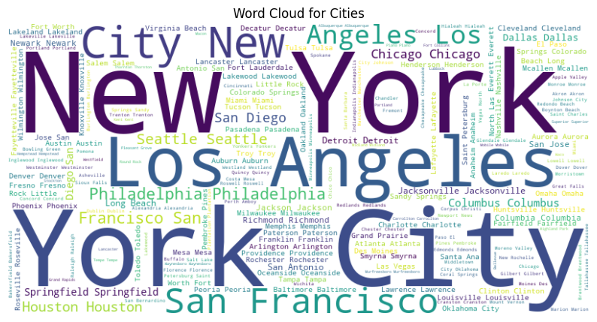

1. Conclusion

* **Key Findings**:
  1. **Binders** and **Paper** are revenue leaders but require margin optimization.
  2. **Appliances** and **Tables** are unprofitable due to excessive discounting.
  3. High sales volume ≠ high profitability.
* **Recommendations**:
  1. Re-evaluate pricing for low-margin products (e.g., **Appliances**).
  2. Limit discounts on loss-making items.
  3. Bundle frequently bought items (e.g., **Binders + Paper**).
  4. Prioritize the **West Region** for resource allocation.